Ideation Phase Empathize & Discover

Date | 25 June 2026
Team ID
Project Name | A Comprehensive Measure of Well-Being
Maximum Marks | 4 Marks

Empathy Map Canvas:
For the Empathy Map Canvas of your Smart Lender – Loan Eligibility Prediction System, choose the primary user as Credit Officer (recommended) because your project mainly helps banks evaluate loan applications. The empathy map should contain the following content. The template sections are Think & Feel, Hear, See, Say & Do, Pain, Gain.

User Persona - Credit Officer

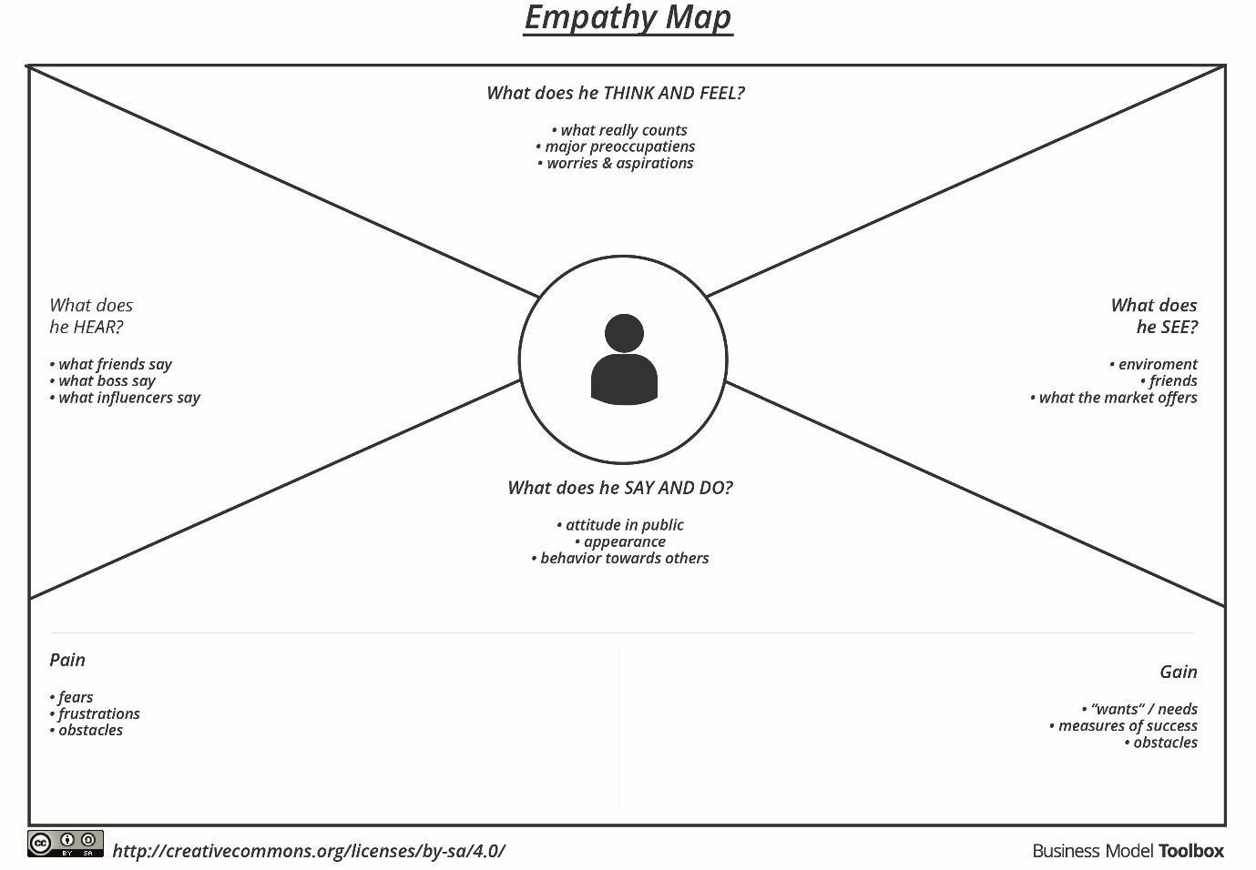
Example:

